**Design Patterns and Principles Hands On**

**Exercise 1: Implementing the Singleton Pattern**

**Scenario:**

You need to ensure that a logging utility class in your application has only one instance throughout the application lifecycle to ensure consistent logging.

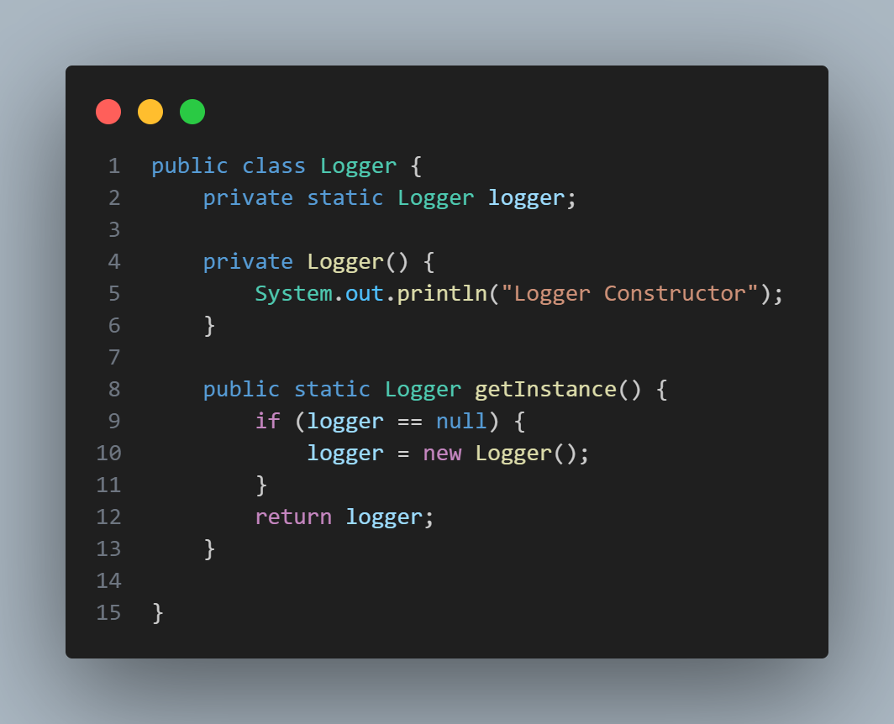

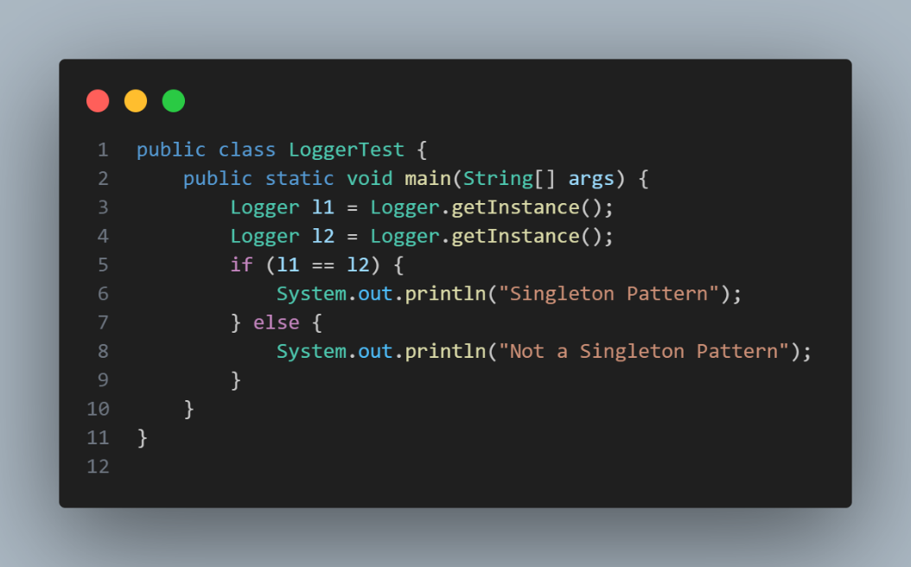

OUTPUT:



**Exercise 2: Implementing the Factory Method Pattern**

**Scenario:**

You are developing a document management system that needs to create different types of documents (e.g., Word, PDF, Excel). Use the Factory Method Pattern to achieve this.

PROGRAM:

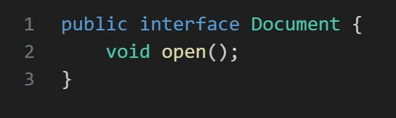

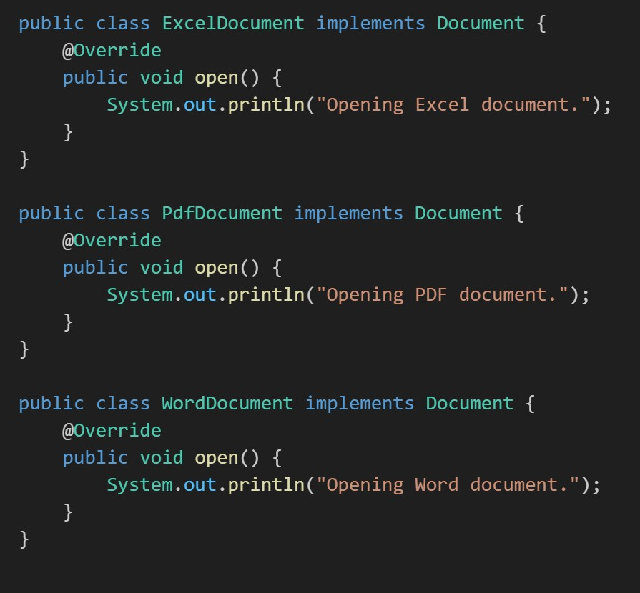

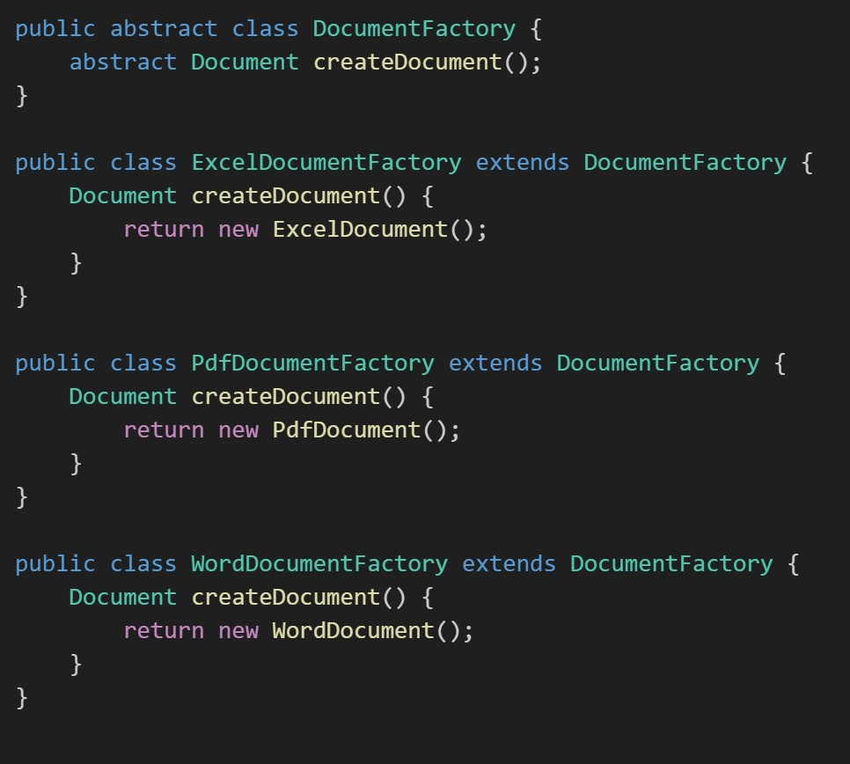

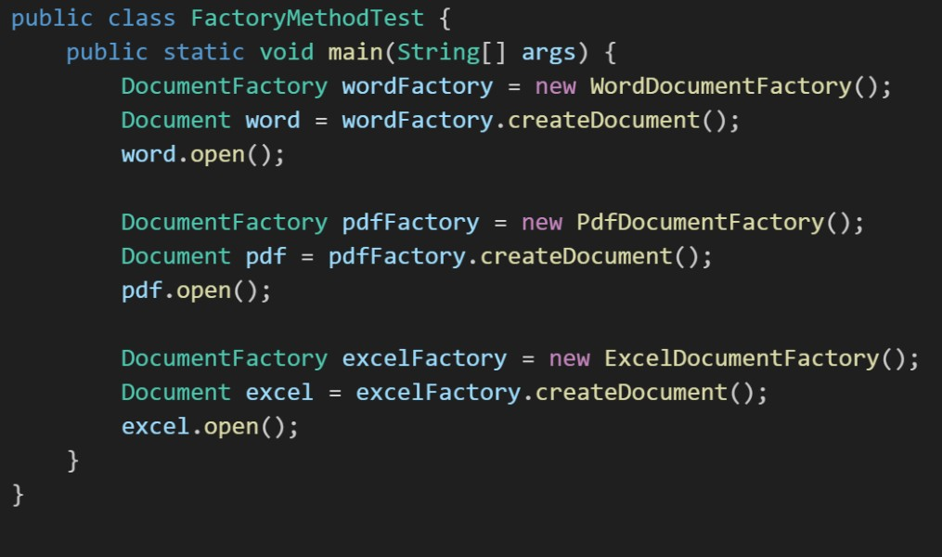

OUTPUT:

